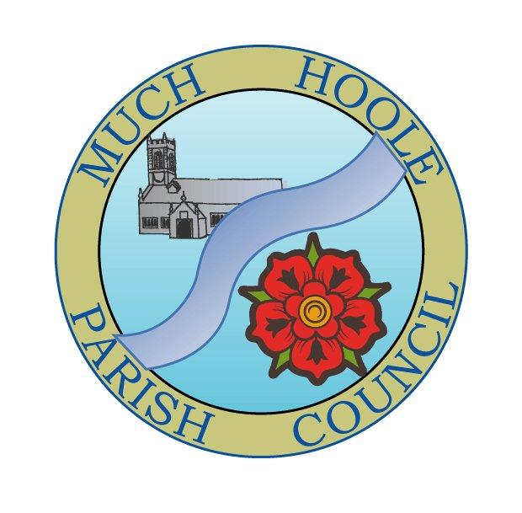 | MUCH HOOLE PARISH COUNCIL  NOTICE OF MEETING
You are hereby summoned to attend the Meeting of Much Hoole Parish Council to be held at 7.30pm on Monday 8th February 2021. The meeting will be held via Zoom video link under emergency powers in force due to the Corona virus legislation

Members of the public wishing to ‘attend’ the meeting may do so by using Zoom and the following login details:
Meeting ID: 935 2393 6522
Passcode: 582852

Russ Weaver, Clerk to the Parish Council

AGENDA
1. | Apologies for Absence  To receive apologies for absence.
2. | Declaration of Interests and Dispensations  - To receive declarations of interest from Councillors on items on the agenda  - To receive written requests for dispensations for disclosable pecuniary interests (if any)  - To grant any requests for dispensation as appropriate
3. | Minutes of the Previous Meetings  To resolve to approve as a correct record the Minutes of the Council Meeting held on the 11th January 2021
4. | Public Time  To invite and listen to issues raised by members of the public.
5. | Off Road Cycle Track  To consider any updates on the Cycle track and resolve any actions required.
6. | Village Hall Update  To receive any updates on the village hall and progress towards its redevelopment
7. | Finance  To resolve to authorise payment of the following:  - To resolve to pay Clerk salary for December 2020 in sum of £226.00 (net)  - To resolve to pay HMRC PAYE for September 2020 in sum of £56.50  - To resolve to pay Clerk’s expenses in sum of £19.35 (December and January)  - To resolve to pay Sustainable Land Management in sum of £235.00 (Tree stump removal)
8. | Grant Applications  - To consider the grant application from MHVH Bowling Club for £500 contribution towards replacement LED floodlighting.  - To consider the grant application from the ‘Here for Humanity Foodbank’ charity
9. | Community Infrastructure Levy (CIL)  To discuss and agree proposals for allocating the remaining CIL money allocated to MHPC.
10. | Newsletter  To agree the content of the draft Newsletter for posting on MHPC Website
11. | Planning  07/2021/00062/DIS January 22, 2021  Application to discharge conditions 4 (BREEAM) and 5 (BREEAM) of planning  permission 07/2017/1644/FUL  Ribble Park Lodge, 150 Liverpool Old Road, Much Hoole, Preston,, Lancashire  PR4 4QB
12. | Local Meetings  To receive reports or notification of any local meetings.
13. | Items for the Next Agenda (for information only)
14. | Date of Next Meeting  The Parish Council to agree the date of the next meeting as 7.30pm Monday 8th March 2021  The format of the meeting will be decided in accordance with Government guidance in force at that time

